**A picture containing clipart

Description generated with very high confidence**

CREATING A SERVICE

DevOps Certification Training

[**support@intellipaat.com**](mailto:support@intellipaat.com)

**+91-7022374614**

**US: 1-800-216-8930(Toll Free)**

**CREATING A SERVICE**

**Steps for Master**

**Step 1:** We will create a nodeport service for our nginx deployment, run the following command:

kubectl create service nodeport nginx –tcp=80:80



**Step 2:** Note down the Nodeport for this service by running the command,

kubectl get svc nginx

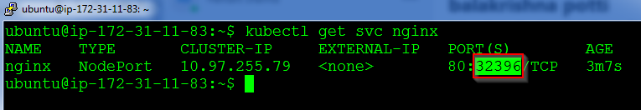

**Step 3:** Verify the working of the service by browsing to the IP address of the master or slave with this port

